Assignment Module 6: Network Security, Maintenance, and Troubleshooting Procedures

🔹 Section 1: Multiple Choice Questions

Q1. What is the primary purpose of a firewall in a network security infrastructure?
Answer: (B) Filtering and controlling network traffic

Q2. What type of attack floods a network with excessive traffic to disrupt operations?
Answer: (A) Denial of Service (DoS)

Q3. Which encryption protocol is commonly used to secure wireless communications?
Answer: (B) WPA (Wi-Fi Protected Access)
👉 Reality check:
- WEP is outdated and weak
- WPA2/WPA3 are the real standards now

Q4. What is the purpose of a VPN in network security?
Answer:
A VPN creates a secure, encrypted connection over the internet to protect data and maintain privacy during communication.

Q5. Which best describes the purpose of a VPN?
Answer: (A) Encrypting network traffic to prevent eavesdropping

🔹 Section 2: True or False

Q6. Patch management involves updating software and firmware regularly
Answer: True

Q7. Regular backups help prevent data loss
Answer: True

Q8. Traceroute identifies packet route and latency
Answer: True

🔹 Section 3: Short Answer

Q9. Steps Involved in Conducting a Network Vulnerability Assessment
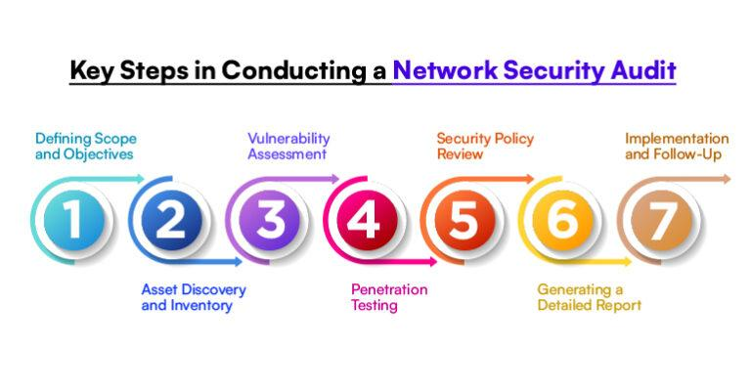
Answer:
- Identify Network Assets
List all devices, servers, routers, and systems connected to the network.
- Scan for Vulnerabilities
Use vulnerability scanning tools to identify weaknesses.
- Analyze Security Risks
Evaluate detected vulnerabilities and determine their severity.
- Review Configurations
Check firewall rules, passwords, access controls, and security settings.
- Apply Security Fixes
Install patches, update firmware, and fix weak configurations.
- Test Security Measures
Verify whether vulnerabilities have been resolved.
- Document Findings
Record vulnerabilities, actions taken, and future recommendations.
🔹 Section 4: Practical Application

Q10. Troubleshoot Network Connectivity Using the ping Command
Step 1: Open Command Prompt
- Press Win + R
- Type cmd
- Press Enter
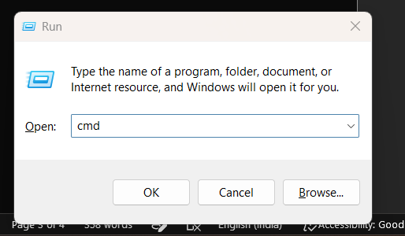

Step 2: Test Local Network
Run:
ping 127.0.0.1
- Checks TCP/IP functionality on the local machine.
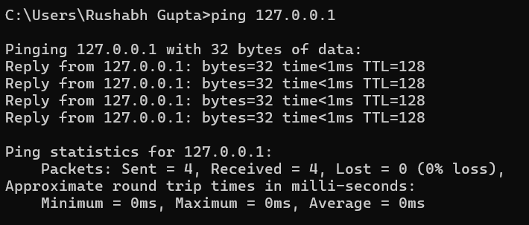

Step 3: Test Router Connectivity
Run:
ping 192.168.1.1
- Verifies communication with the router.
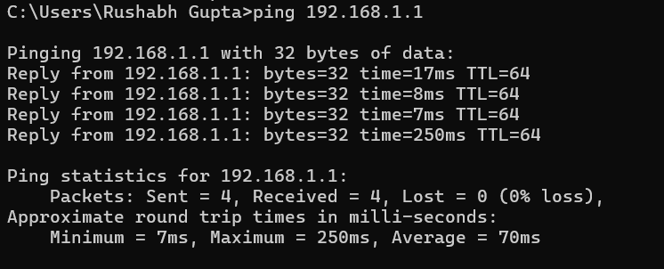

Step 4: Test Internet Connectivity
Run:
ping 8.8.8.8
- Checks external internet access.
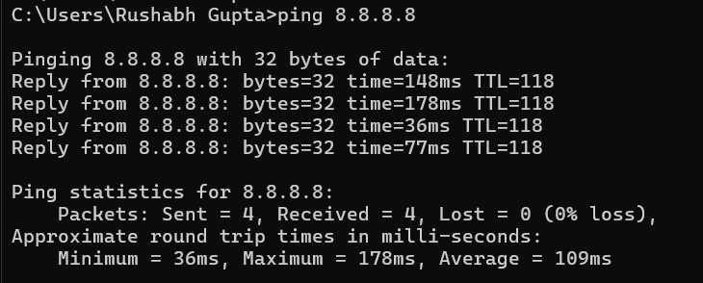

Step 5: Test DNS Resolution
Run:
ping google.com
Interpretation:
- If IP ping works but domain fails → DNS problem
- If both fail → network or ISP issue
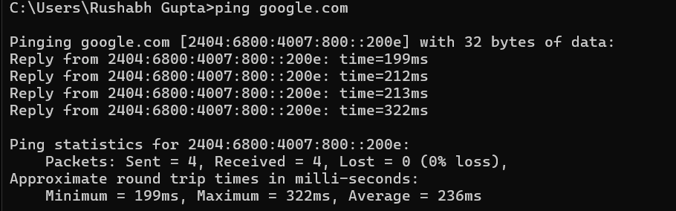

🔹 Section 5: Essay

Q11. Importance of Regular Network Maintenance
Answer:
Regular network maintenance is essential for ensuring network performance, security, and reliability. Without maintenance, networks become slow, vulnerable, and unstable.
Importance:
- Improves network performance
- Prevents security breaches
- Reduces downtime and failures
- Protects important data
- Extends hardware lifespan

Key Maintenance Tasks:
- Updating software and firmware
- Monitoring network performance
- Performing regular backups
- Checking firewall and security settings
- Replacing faulty hardware
- Scanning for malware and vulnerabilities
- Managing cables and cooling systems

Conclusion:
Proper network maintenance ensures stable communication, strong security, and efficient operation of the entire network infrastructure.

